**Solution space**

$(N,MS,\left\{M_{k}\right\},\left\{\left(x_{i},y_{i}\right)\right\},\left\{(x_{j}^{k},y_{j}^{k})\right\})$

$N$ denotes the number of clusters

$MS$ denotes the number of mobile sinks

$M_{k}$ denotes the number of RVP for mobile sink $k=1,…MS$

$MS$ denotes the number of mobile sink

**Example**

(4,4,1,7,1,2, 3,9,2,8, 9,1,1,2,2,3)

We have 3 clusters located in (4,4,1,7,1,2)

We have 2 mobile sinks

The first mobile sink has 2 RV points (3,9,2,8)

The second mobile sink 3 RV points (9,1,1,2,2,3)

This representation implies very very very huge solution space

$2N$ + $\sum_{k=1}^{MS}{(2M_{k})}$

2*3+(2*2+2*3)=6+4+6=16

This proves that the solution space is $f(N,M_{1},M_{2},…M_{MS})$

Each solution will be evaluated based on the following objective functions:

1. Minimization of energy consumption resulted from sending data from nodes to cluster heads
2. Minimization of energy consumption resulted from sending data from cluster head to RV points
3. Minimization of distribution of energy consumption among the node
4. Minimization of traveling time of mobile sink
5. Minimization of number of mobile sink

We assume for each RVP the mobile sink will stop in a time that is proportional to the data that will be collected (proportional to the number of nodes associated with the given cluster )

Energy is consumed at each sensor whenever a data packet is sent or received. The consumed energy is calculated according to number of bits in the packet for transmission and receiving, and to both the number of bits in the packet and the distance between the sender and receiver in the case transmission. We also assume that the sensors can operate in one of two modes, first is the high energy mode for communicating between cluster heads and sinks and the second is low energy mode for communicating within clusters.

This is according to the radio energy dissipation model presented in Equation (1) and (2) that are given in [1].

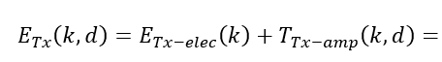

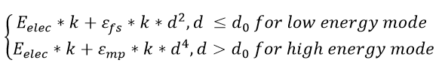

(1)

To receive *k* bits’ message, the energy consumption is:

= (2)



Tightly coupled